# Project 2 (15%)

## Problem domain: Algorithmic Complexity and Space-Speed Trade Off

The objective of this project is to enable you to apply the concept of algorithmic complexity to given problems and work out a compromise in a situation where a space-speed trade-off exists. You are required to do the following tasks:

1. Work out the computational complexity of an algorithm.
2. Assess time-space trade-off choices in a problem.
3. Produce a short report outlining response to formative feedback.
4. Add your solutions to your portfolio using the portfolio template provided.

This project represents 15% of the total marks available in this module.

**Note that the deadline for completion of this project is the same as the submission date of your portfolio. However, you are advised to complete it by 25th October 2021 (i.e., Week 14) to avoid increasing your workload as other projects will be given out throughout the semester.**

### Task 1

Consider the following algorithm fragment written in ADL and calculate its computational complexity with justification and represent it in Big-O notation.

**for** i **←** 1 **to** n **by** 1 **do**

**for** j **←** 1 **to** i **by** 1 **do**

**for** k **←** 1 **to** j **by** 1 **do**

x = x + 1

**end**

**end**

**end**

### Task 2

Consider the data shown below, which gives the different flights of an airline. Discuss different ways of storing the data to decrease the time in executing the following:

* Find the origin and destination of a flight, given the flight number.
* Given city A and city B, find whether there is a flight from A to B, and if there is, find its flight number.

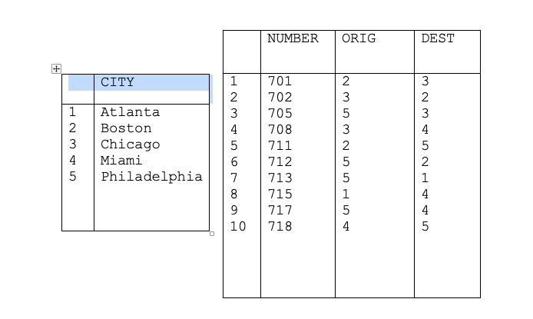

## Grading Criteria

This work will be graded using the criteria given below.

|  |  |
| --- | --- |
| **Criteria** | **Marks** |
| An assessment of time-space trade-off choices | 60 |
| Ability to work out the complexity of an algorithm | 35 |
| Incorporation of formative feedback | 5 |